DRUMBEAT

- No drumming experience necessary!
- Build on Resilience through Rhythm
- Come and learn some core beats
- Discover Relationships with others using Music, Beliefs, Emotions, Attitudes and Thoughts
- Share your skills with your children through learning body percussion



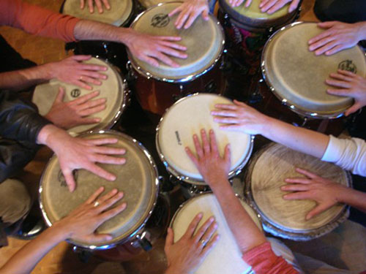

Every Thursday
12:30pm – 2:00pm

For 8 weeks starting
7th February & finishing 28th March 2019

Free Children’s Activities on premises

FSN Family Centre
2 High Street Waratah

Free Afternoon
Tea

Thou-Walla Schools as Community Centre
Irrawang Public School
Geer Street, Raymond Terrace

Places are limited! To book, please phone Gina on 4987 4666

